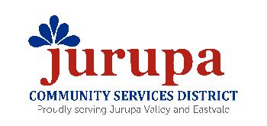
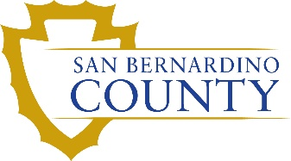
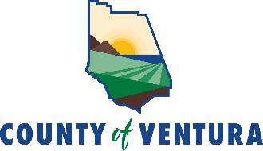

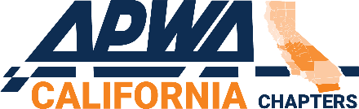


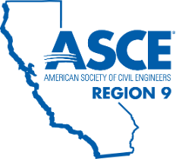



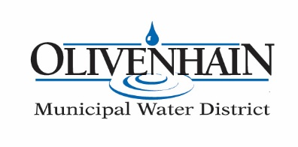
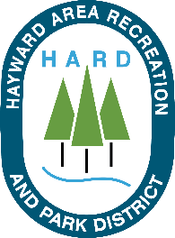
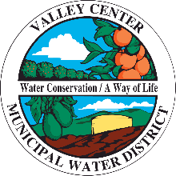

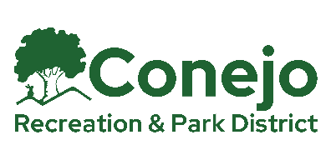
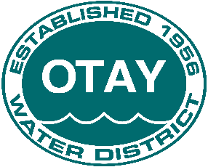
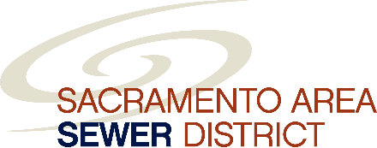


July 25, 2025

The Honorable Anna Caballero, Chair
Senate Appropriations Committee
1021 O Street, Suite 7620
Sacramento, CA 95814

Re: AB 339 (Ortega): Local public employee organizations: notice requirements
As amended 7/15/25 – OPPOSE
Set for hearing 7/15/25 – Senate Appropriations Committee

Dear Senator Caballero:

On behalf of the Urban Counties of California (UCC), California State Association of Counties (CSAC), Rural County Representatives of California (RCRC), Association of California Healthcare Districts (ACHD), California Special Districts Association (CSDA), League of California Cities (CalCities), Public Risk Innovation, Solutions, and Management (PRISM), Association of California Water Agencies (ACWA), County Health Executives Association of California (CHEAC), California State Sheriffs’ Association (CSSA), Contra Costa County, Fresno County, Lake County, Los Angeles County, Merced County, Placer County, Riverside County, Sacramento County, San Joaquin County, San Mateo County, Santa Clara County, San Bernardino County, Ventura County, South San Joaquin Irrigation District, American Council of Engineering Companies of California, California Geotechnical Engineering Association (CalGeo), the American Institute of Architects California, Transportation California, California Building Officials (CALBO), California Association of Recreation and Park Districts (CARPD), California Transit Association, California Association of Sanitation Agencies (CASA), the California and Nevada Civil Engineers and Land Surveyors Association (CELSA), Helix Water District, the California Association of Public Hospitals and Health Systems (CAPH), California Animal Welfare Association (CalAnimals), Bay Area Air District, California-Nevada Section, American Water Works Association (CA-NV AWWA), the Jurupa Community Services District, the American Public Works Association – California Chapters, the California Park and Recreation Society (CPRS), Contra Costa Water District, and the American Society of Civil Engineers (ASCE)-Region 9, Coachella Valley Water District, the California Association of Joint Powers Authorities (CAJPA), Valley West Water District, Olivenhain Municipal Water District, Valley Center Municipal Water District, Otay Water District, Vista Irrigation District, Tahoe City Public Utility District, Hayward Area Recreation and Park District, Conejo Recreation and Park District, and Sacramento Area Sewer District, we write in respectful opposition to Assembly Bill 339, as recently amended. This measure would require the governing body of a local public agency (non-school) to provide written notice to the employee organization no less than 60 days prior to issuing any request for proposals, request for quotes, or renewing or extending an existing contract to perform services that are within the scope of work of the job classifications represented by the recognized employee organization, and to engage in potentially extensive and lengthy negotiations regarding each of those actions upon request. AB 339 would be impractical in its execution, is unworkable for ensuring provision of public services, and undermines local labor negotiations. In addition, and importantly for your committee, AB 339 imposes significant costs to local agencies, including new noticing requirements, extended labor negotiations, and likely delays in services and projects.

AB 339 applies to any contract that is within the scope of work of any job classification represented by a recognized employee organization; for local agencies with represented workforces, this essentially means nearly every contract would be subject to notice and possible meet and confer. This provision is considerably broader than the existing requirement for bargaining under the Meyers-Milias Brown Act (MMBA); under existing law, where contracting out is legally permissible, local agencies are still required to “meet and confer in good faith” with any affected bargaining unit prior to making any decision that is within the scope of representation. (Gov. Code, §§ 3505.) However, existing law incorporates several common-sense limitations upon the requirement to meet and confer – including where there is a longstanding past practice of contracting for particular services, or where contracting out is contemplated in the applicable MOU. AB 339 subverts these well-settled principles to the detriment of local public services by expanding opportunities for meet and confer negotiations, which – in addition to the bill’s notification requirements – will expose local agencies to additional costs that result from a new and potentially significant workload increase. AB 339 may even impact the ability of local agencies to contract with the state for cooperative service provision.

It is important to note that an administrative remedy is already available to recognized employee organizations when they believe that a local agency has neglected to meet existing notification and meet and confer requirements regarding contracting. Failure to adhere to existing requirements under the MMBA and related case law subjects a local agency to a potential unfair labor practice charge at the Public Employment Relations Board (PERB).

The lack of definition of emergency or exigent circumstances in AB 339 undermines existing emergency contracting authority; further, this provision only applies to the initial notice requirement – not the meet and confer provisions – making the provision nearly meaningless in an emergency circumstance. You are undoubtedly aware of the considerable responsibility assumed by local agencies in a natural disaster, public health emergency, or other local crisis. As first responders, local agencies rely on existing statutes that allow for considerable flexibility to ensure the safety and well-being of our communities. Again, AB 339 would prove costly for local agencies attempting to focus available resources on response and recovery during an emergency.

In addition, AB 339 will significantly delay public works projects and could grind building permit processing, design, and construction of needed housing or infrastructure projects to a halt. Public works projects involve multiple phases of design, which require a diverse array of services – including site assessments, geotechnical services, land surveys, plan check, and traffic studies, to name just a few – that cannot be fully known until earlier phases have completed, making it impossible for agencies to complete all of AB 339's notification pauses at the outset of a project. These notices would therefore be compounded, causing projects to be delayed by multiples of the 60-day pause before a shovel ever touches the ground. Since the bill applies to any services within the scope of work of the job classifications represented by the recognized employee organization, this will include instances in which none of an agency's employees currently, or ever, have performed those services. The vast majority of agencies lack the resources and expertise to have 100 percent of their design needs performed by its own engineers, planners, and other design professionals on staff. Should one of these agencies need to transfer responsibility for conducting vital design services – plan checking an application for a housing development permit, for example – they could be left without qualified staff to perform those essential functions for at least 60 days.

The bill also deters local agencies from working in partnership with local community organizations, who are at the front lines of providing critical local services, and who are already under scrutiny by the federal government, adding considerable uncertainty to their ongoing financial viability. We value our partnerships with these organizations, as they often provide culturally competent outreach and direct services to groups that can be difficult to serve; these partnerships allow local agencies to maximize federal, state, and local resources to ensure that services reach those who need them most.

Finally, sponsors continue to assert that documents associated with a Request for Proposals (RFP), Request for Quotes (RFQ), contract extensions, and contract renewals are not disclosed to the public. In truth, RFPs and RFQs are typically public by nature and subject to competitive bidding processes and regulations, while contracts are almost always disclosable public records under the Public Records Act. We dispute that local agencies are inappropriately withholding public records and further disagree that local agencies are failing to comply with existing notification requirements under the MMBA. If either were true, there are already existing remedies for sponsors to address these issues.

Like previous unsuccessful proposals that have sought to undermine local agencies’ ability to contract for public services, AB 339 represents a sweeping change to the fundamental work of local governments, but we remain unaware of a specific, current, and widespread problem that this measure would resolve or prevent. We are keenly aware, though, of the very real harm that could result from this measure. AB 339 will not improve services, reduce costs, or protect employees. As a result, we are opposed. Should you have any questions about our position, please reach out directly.

Sincerely,
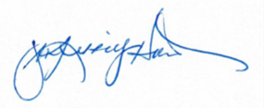
Jean Kinney Hurst  Legislative Advocate  Urban Counties of California | Eric Lawyer  Legislative Advocate  California State Association of Counties
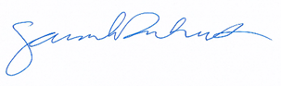  Sarah Dukett  Policy Advocate  Rural County Representatives of California | 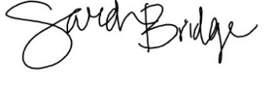  Sarah Bridge  Legislative Advocate  Association of California Healthcare Districts
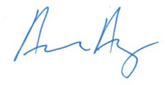  Aaron Avery  Director of State Legislative Affairs  California Special Districts Association | 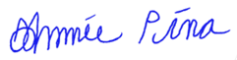  Johnnie Pina  Legislative Affairs, Lobbyist  League of California Cities
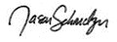  Jason Schmelzer  Legislative Advocate  Public Risk Innovation, Solutions, and Management | 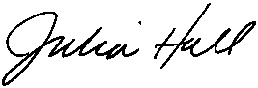  Julia Bishop Hall  Director of State Legislative Relations  Association of California Water Agencies
Farrah McDaid Ting  Deputy Director of Policy  County Health Executives Association of California | 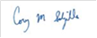  Cory M. Salzillo  Legislative Director  California State Sheriffs’ Association
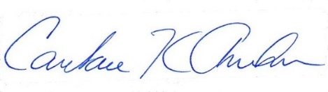  Candace Andersen  Chair, Contra Costa County Board of Supervisors | 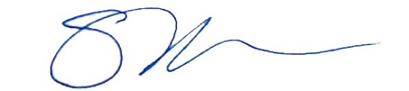  Susan Parker  County Administrative Officer  County of Lake
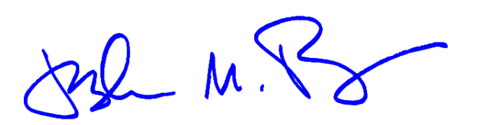  Joshua Pedrozo  Chairman  Merced County Board of Supervisors | 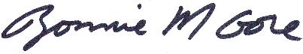  Bonnie Gore  Chair (District 1)  Placer County Board of Supervisors
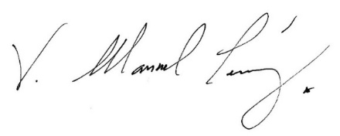  Supervisor V. Manuel Perez, Chair  Riverside County Board of Supervisors | Elisia De Bord  Governmental Relations and Legislative Officer  County of Sacramento
  Paul Canepa  Chair  San Joaquin County Board of Supervisors | 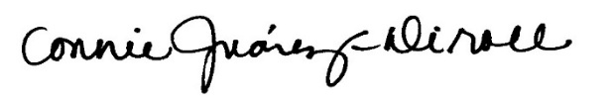  Connie Juárez-Diroll  Chief Legislative Officer  County of San Mateo

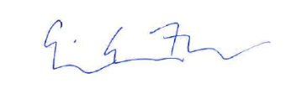  Erin Evans-Fudem  Legislative Deputy County Counsel  Office of the County Counsel  County of Santa Clara | 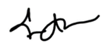  Eric P. Angstadt  CELSA  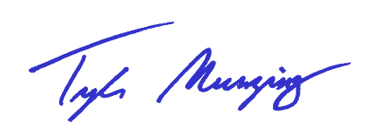  Executive Secretary
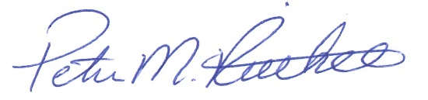  Peter M. Rietkerk  General Manager  South San Joaquin Irrigation District | Tyler Munzing  Director of Government Affairs  American Council of Engineering Companies of California
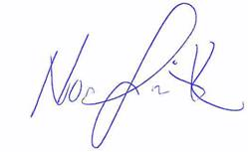  Noah Smith, PE, GE  President  California Geotechnical Engineering Association | 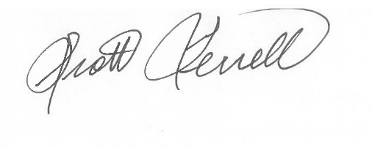  Scott Terrell  Director of Government Relations  The American Institute of Architects California
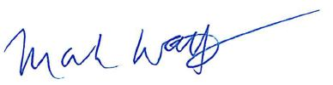  Mark Watts  Legislative Advocate  Transportation California | 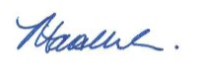  Matthew Wheeler, DPPD  Executive Director  California Building Officials (CALBO)
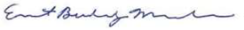  Buddy Mendes, Chairman  Fresno County Board of Supervisors  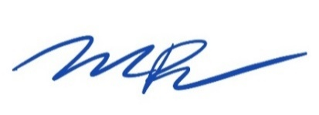 | 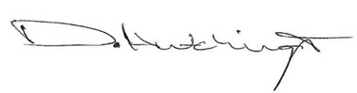  Dane Hutchings  Legislative Representative  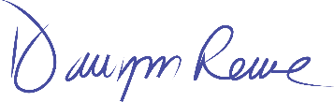  California Association of Recreation and Park Districts
Michael Pimentel  Executive Director  California Transit Association | Dawn Rowe  Chairman  County of San Bernardino
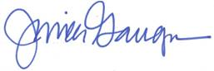  Jessica Gauger  Director of Legislative Advocacy & Public Affairs  California Association of Sanitation Agencies | 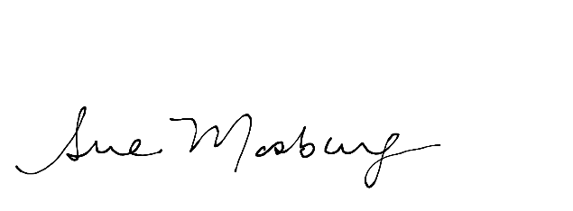  Sue Mosburg  Executive Director  American Water Works Association, California-Nevada Section
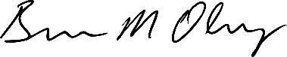  Brian Olney  General Manager  Helix Water District | 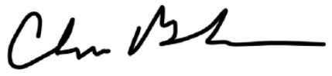  Chris Berch, P.E.  General Manager  Jurupa Community Services District
  Karen Lange  Legislative Advocate  California Animal Welfare Association | 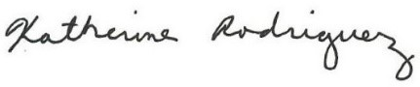  Katie Rodriguez  Vice President of Policy and Government Relations  California Association of Public Hospitals and Health Systems (CAPH)
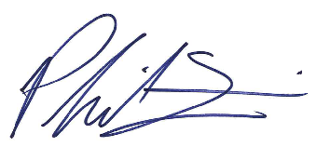  Philip M. Fine, Ph.D.  Executive Officer/APCO  Bay Area Air District | 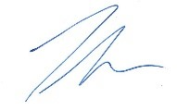  Joubin Pakpour  Director  American Public Works Association — California Chapters
Elizabeth Espinosa  Legislative Advocate  County of Ventura | 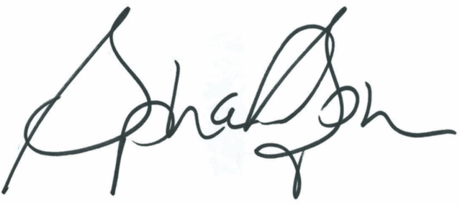  Stephanie Stephens  Exeuctive Director  California Park and Recreation Society
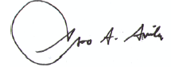  Ernesto A. Avila, Board President  Contra Costa Water District | 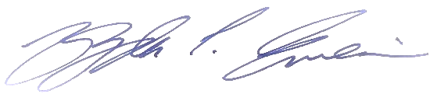  Yazdan Emrani, Region 9 Director  American Society of Civil Engineers (ASCE-Region 9

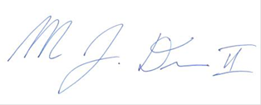  Marvin J. Deon II, Chief Legislative Representative  County of Los Angeles | 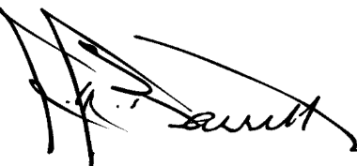  J.M. Barrett, General Manager  Coachella Valley Water District
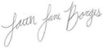  Faith Borges, Legislative Advocate  California Association of Joint Powers Authorities (CAJPA) | 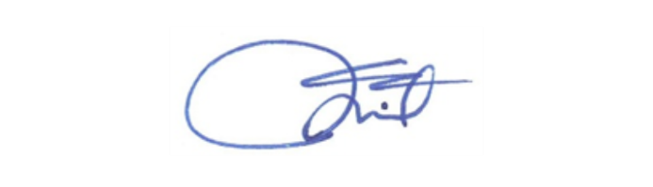  John Thiel, General Manager  West Valley Water District
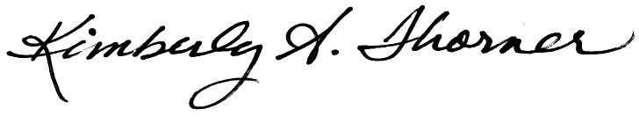  Kimberly A. Thorner, General Manager  Olivenhain Municipal Water District |   Gary Arant, General Manager  Valley Center Municipal Water District
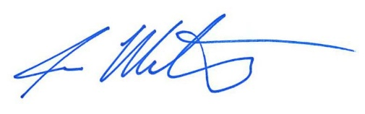  Jose Martinez, General Manager  Otay Water District | 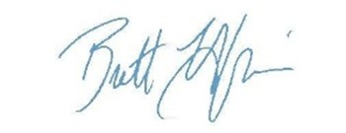  Brett Hodgkiss, General Manager  Vista Irrigation District
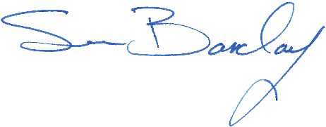  Sean Barclay, General Manager  Tahoe City Public Utility District | 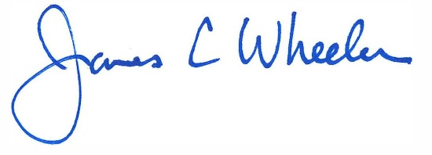  James Wheeler, General Manager  Hayward Area Recreation and Park District
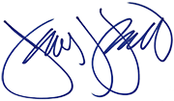  Jim Friedl, General Manager  Conejo Recreation and Park District | HOLD – Sacramento Area Sewer District
HOLD – Association of General Contractors

cc: Members and Consultants, Senate Appropriations Committee
The Honorable Liz Ortega, California State Assembly

